**Dynamic Equilibrium**

* Many reactions are reversible, initially only the forward reaction is occurring but as products form, the reverse reaction will start to occur.
* Initially the forward reaction is fast due to high reactant concentrations, but as the reactants are used up, the rate slows. Initially the reverse reaction is slow but as the reaction progresses it speeds up. These observations can be explained using collision theory.
* In a closed system, the rate of the forward and reverse reaction will eventually become equal. At this point, the reaction has reached an **equilibrium**. This is shown in the graphs below:

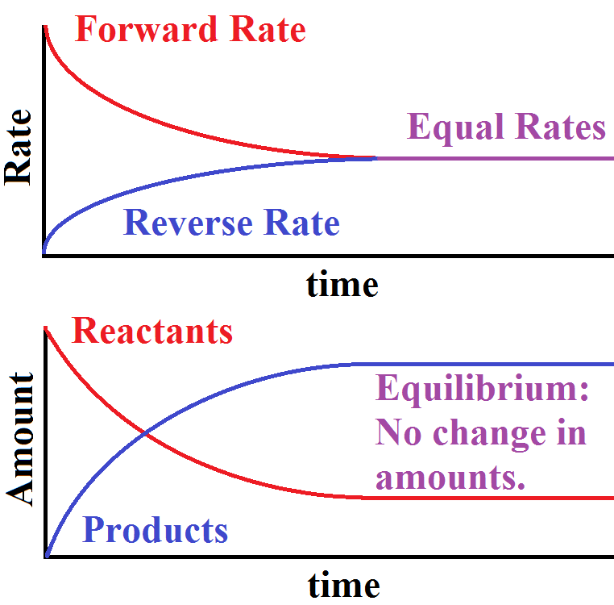



When considering graphs involving equilibrium systems it is essential to check if the data presented is rate vs time or concentration vs time

* When a reversible system has reached equilibrium the concentrations of the reactant and products are **constant**. Therefore, when at equilibrium the properties are constant, and the reaction **appears** to have stopped.
* 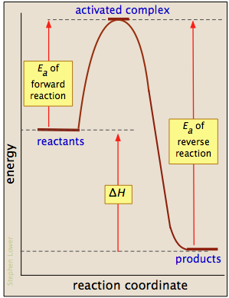In some cases, there can still be significant amounts of the reactants when equilibrium is reached.
* In reversible reactions, the reaction in one direction will be **exothermic** and the reaction in the other direction will be **endothermic**.
* Since the activation energies of the forward and reverse reactions are always different, **equilibrium almost never occurs when the concentrations of reactants and products are equal**.

**The Dynamic Nature of Equilibrium**

* Although the reaction appears to have stopped at equilibrium, both the forward and reverse reactions are still occurring, just at the same rate. The system is referred to as being in **dynamic equilibrium**.
* During dynamic equilibrium
  + forward and reverse reaction rates are the same
  + there will be a mixture of products and reactants
  + concentrations of reactants and products are constant, but not equal
  + products are continuously turning into reacts and vis versa (bonds are continuously being broken and formed)
  + neither the forward or reverse reactions have gone to completion
* A dynamic equilibrium can only be reached in a **closed system**.

**Characteristics of reversible reactions**

* These reactions proceed both directions (forward and reverse direction),
* Neither reaction will proceed to completion,
* 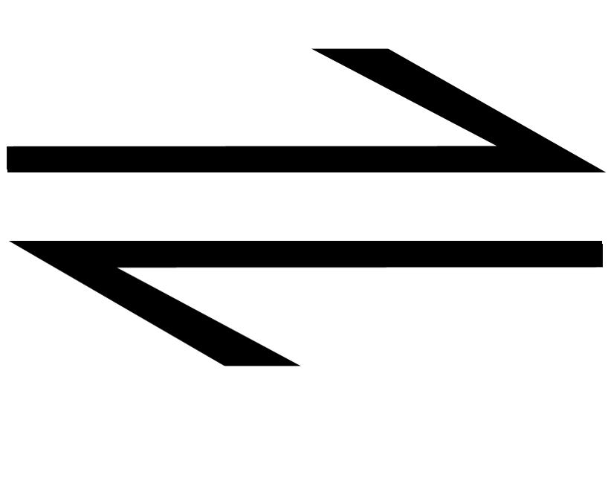The arrow ( )is placed between reactants and products,
* If it occurs in a closed system, dynamic **equilibrium** will be reached, where the rate of the forward reaction and the rate of the reverse reaction are equal. At this point, there concentrations of reactants and products are constant no further change will be apparent to the observer.

**The Extent of the Reaction**

* Many reactions are reversible and reach a dynamic equilibrium in a closed system. But not all reactions proceed to the same extent.
* For example, when a strong acid such as HCl is added to water virtually all the reactant is converted into products (ions). However, if a weak acid, such as ethanoic acid is added to water only a small proportion of the reactant is converted into product (ions).
* Extent of a reaction gives no indication regarding the rate of the reaction. It only indicates the amount of reactant converted to product, not how fast the equilibrium was reached.

**Expert Tip**

When dealing with gaseous equilibrium systems. It is common to use **partial pressure** of the reactants and products as an indirect measure of the concentrations.

